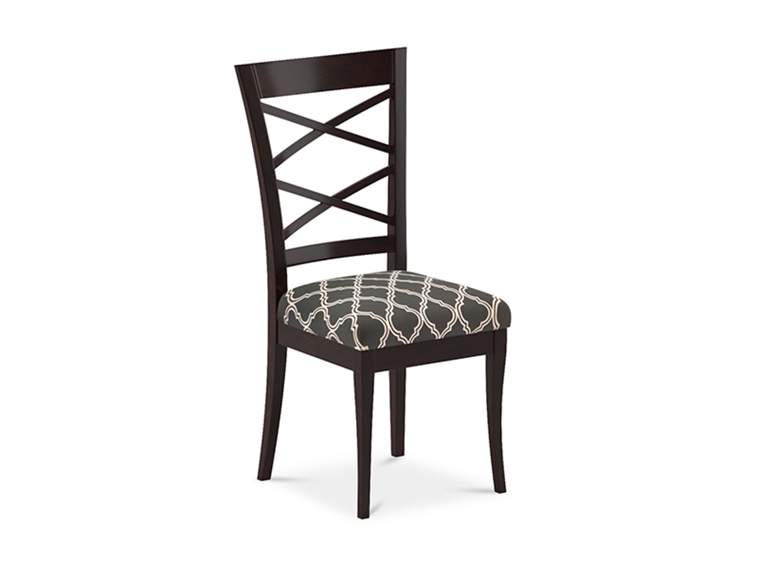

# Dining Chair Colombo Double XX

# Dining Chair Colombo Double XX

PKR 22,327PKR 26,900

Design:

[Colombo](https://interwood.pk/colombo-dining-set.html)

Delivered in :04 - 06 Working Days

Designed to add life to any space, the Colombo chair is a smart and contemporary choice for any dining room. This classic Walnut chair boasts both tastefulness and style. It is made with high-quality and durable materials, ensuring that it lasts for the long run. The bright natural light complements the Brown tones and ensures that the room looks spacious and inviting at the same time.

### **Features**

* Durable Fabric on Seat
* Sturdy Wooden Frame and Legs
* Armless Design
* Double Cross Design on Chair Back
* Pair with Colombo Dining Table or use as an Accent Chair
* Spot Clean with Damp Cloth if Spill occurs on Seat
* A 1-year warranty is applicable on this product.

### **Specification**

* Size:
  + 502 W x 486 D x 1020 H (mm)
* Fabric upholstery seat
* Acacia wood
* Walnut Polish Finish

**Note:**The actual colours may vary from those shown depending on the device you are using to view the product or the angle of the item is photographed.